GLAZIA
Welcome / Hub Registration — Design Handoff
Source-accurate documentation for the supplied 1280 × 720 composition and editable SVG assets
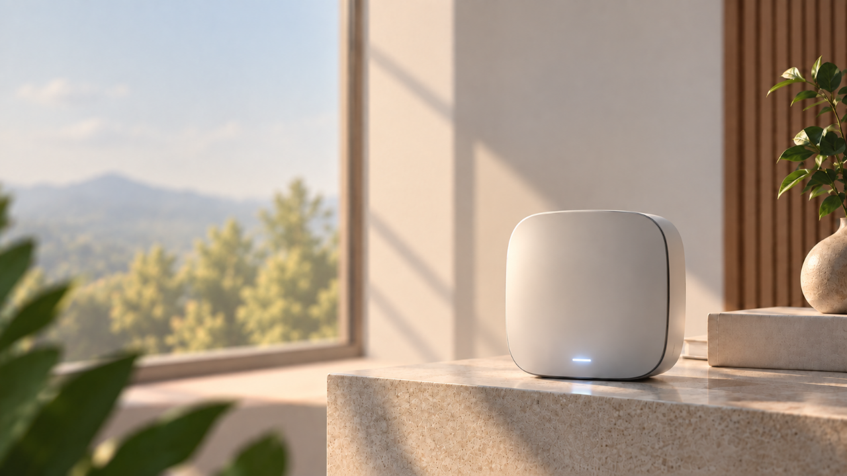
Master design frame: 1280 × 720 px

1. Master Canvas & Background
Item | Value | Source
Master UI frame | 1280 × 720 px | Supplied full-page background SVG
Background source SVG | 1280 × 720 px | a356f846-738d-4fe7-bc6a-d1cb0eb2d69f 2.svg
Reference PNG | 1280 × 723 px | db6bbd89-cfba-4f77-9912-b3ca1fef4d65 2.png
Production background | Use 1280 × 720 source SVG/render | Avoid the extra 3 px in the 1280 × 723 reference
Treatment | Warm natural daylight, shallow depth of field, soft geometric window shadows | Visible in supplied background
Background usage: place the supplied background as a full-bleed layer at 0,0. Do not add an additional overlay unless required by the implementation. The supplied scene contains the off-white hub, stone pedestal, window, mountain/greenery view, wood slats and plant.

Production background preview:

2. Typography
Important source note: the supplied standalone text exports are vector outlines/path geometry rather than live text, so the original font family is not embedded in those individual SVGs. The values below are implementation references consistent with the editable Glazia page source used in the same design system.
Role | Font | Size | Weight | Color
Primary page heading / Welcome | Space Grotesk | ~40–42 px | 700 | #0D141A / #647184 split
Supporting body copy | Inter | ~16–18 px | 400 | #0D141A / #647184
Small data / MAC / footer labels | IBM Plex Mono | ~10 px | 400–500 | #4A453C / #5F6973
Registration title | Inter / Space Grotesk | ~18–20 px | 600–700 | #181818
Secondary registration text | Inter | ~12–14 px | 400 | #6C655A
CTA label | Inter | ~15–16 px | 600 | #FFFFFF
Text-rendering rule: if implementing live text, use the type values above; if preserving the exact supplied artwork, keep the original SVG outline assets because that preserves their exact path geometry.

3. Color & Surface Tokens
The palette below is directly observed in the supplied SVG assets. Where a color is used for a specific asset, the usage is called out.
HEX | Role | Swatch
#0D141A | Primary dark ink / logo / icons
#0A0B10 | Dark logo variant / strong graphic paths
#151D22 | Dark surface / CTA-related source artwork
#181818 | Registration heading artwork
#050505 | CTA dark
#4A453C | MAC-address text / warm dark neutral
#6C655A | Supporting registration text
#647184 | Secondary / muted body text
#5F6973 | Small gray text / editorial details
#56606A | Secondary stroke / gray detail
#F7F7F7 | Help button / light pill surface
#E7E2D5 | Setup pill background
#FFFFFF | Card / QR / light surfaces

Surface / effect guidance
- Glass/card effect: the supplied card asset uses a white translucent gradient with approximately 0.66 → 0.42 opacity and a white stroke at roughly 0.55 opacity.
- CTA: the supplied CTA is a 392 × 58 px pill with a dark horizontal gradient and white outlined/path text.
- Help: the supplied help button base is 125 × 52 px with #F7F7F7 at 0.86 opacity and #0D141A icon strokes.
- Setup pill: 108 × 34 px, #E7E2D5.

4. Component Inventory & Exact Source Dimensions
Asset | W | H | Use / meaning | Notes
mac-address.svg | 169 | 12 | MAC address line | Text is outline/path artwork
qr-code.svg | 236 | 233 | QR artwork + corner scan brackets | 236 × 233 px; dark QR pattern
Scan to Register the Hub.svg | 349 | 29 | Registration title | Text is outline/path artwork
Setup.svg | 37 | 13 | Setup label | Text is outline/path artwork
to connect the hub..svg | 138 | 12 | Registration supporting text
Vector.svg | 89 | 81 | Compact Glazia logo mark
Vector(1).svg | 125 | 52 | Help pill background variant
Vector-1.svg | 125 | 52 | Help pill background variant
Vector-2.svg | 115 | 104 | Large Glazia logo mark
Vector-3.svg | 418 | 553 | Registration card/background surface | White translucent gradient surface; 418 × 553 px
Vector-4.svg | 108 | 34 | Setup pill background
Vector-5.svg | 69 | 63 | Compact Glazia logo mark
cta-button.svg | 392 | 58 | Simulate Setup Complete CTA | 392 × 58 px pill; white path text
FOOTER(1).svg | 424 | 15 | Bottom footer line + BUILT FOR A SAFER TOMORROW GLAZIA | 424 × 15 px
Group(3).svg | 19 | 17 | Help/headset icon | Text is outline/path artwork
Group 37.svg | 397 | 318 | Welcome content block: GLAZIA logo + Welcome to Glazia + supporting copy | Text is outline/path artwork
Group-1.svg | 19 | 17 | Help/headset icon variant | Text is outline/path artwork
Help.svg | 36 | 16 | Help label | Text is outline/path artwork
Help-1.svg | 36 | 16 | Help label variant | Text is outline/path artwork
a356f846-738d-4fe7-bc6a-d1cb0eb2d69f 2.svg | 1280 | 720 | Full 1280 × 720 background source

5. Registration Card — Build Specification
Element | Exact source data | File
Outer card asset | 418 × 553 px | Vector-3.svg
Card surface | White translucent gradient; top-left ~0.66 opacity → bottom-right ~0.42 opacity | Vector-3.svg
Card border | White stroke, ~55% opacity, 1.5 px | Vector-3.svg
Setup pill | 108 × 34 px; #E7E2D5 | Vector-4.svg
Registration title | 349 × 29 px path artwork; dark #181818 | Scan to Register the Hub.svg
Subtext | 138 × 12 px path artwork; #6C655A | to connect the hub..svg
QR module | 236 × 233 px; #161616 / #FBFAF7 | qr-code.svg
MAC line | 169 × 12 px; #4A453C | mac-address.svg
CTA | 392 × 58 px; dark gradient; white label | cta-button.svg

Suggested layout logic
- Keep the registration card visually centered inside the right-side composition and preserve generous whitespace around the card.
- Use the QR asset as a single grouped vector so the pattern and scan brackets remain aligned.
- Keep the MAC address directly under the QR module with consistent center alignment.
- Use the CTA as the final action block; preserve its 392 × 58 px source proportion.

6. Left Content, Help & Footer
Component | Source size | Observed styling | Usage
Welcome content — Group 37.svg | 397 × 318 px | #0D141A + #647184 split, large display text, logo above | Main left information block
Alternative welcome block — Group(2).svg | 395 × 480 px | Includes dark Get Started CTA | Alternative onboarding state
Help button base — Vector(1).svg / Vector-1.svg | 125 × 52 px | #F7F7F7, ~86% opacity, rounded pill | Top-right help control
Help icon — Group(3).svg / Group-1.svg | 19 × 17 px | #0D141A stroke, rounded line caps | Inside help control
Help label — Help.svg / Help-1.svg | 36 × 16 px | #0D141A | Inside help control
Footer — FOOTER(1).svg | 424 × 15 px | Dark fine rule + microcopy | Bottom-right editorial footer

Asset replacement guidance
Use the supplied logo/vector assets directly. Do not redraw the GLAZIA mark or substitute a different wordmark. For the background, use the supplied 1280 × 720 source SVG or its exact 1280 × 720 render so the scene and lighting stay unchanged.

7. Source Asset Preview
Selected previews of the supplied component exports are included below. The original vector files are included in the handoff ZIP.
mac-address.svg
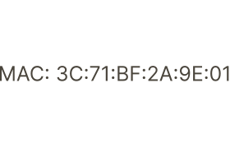
qr-code.svg
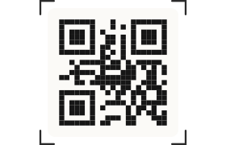
Scan to Register the Hub.svg

Setup.svg

to connect the hub..svg

Vector.svg
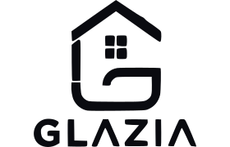
Vector(1).svg

Vector-1.svg
Vector-2.svg
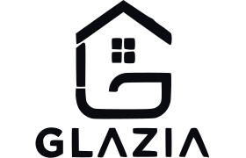
Vector-3.svg

Vector-4.svg

Vector-5.svg
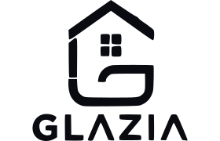

8. Figma Implementation Checklist
- Frame: 1280 × 720 px.
- Background: full-bleed 1280 × 720 supplied source.
- Import supplied SVGs at 1:1 source dimensions before scaling.
- Keep logo, QR, title, MAC line, CTA, help control and footer as separate layers/groups.
- Preserve vector paths for exact logo/QR/CTA appearance; use live text only when a typographic replacement is required.
- Use 8 px as the base spacing rhythm; keep the visual hierarchy airy and minimal.
- Avoid adding shadows/gradients that are not present in the supplied source assets.
- For the supplied 1280 × 723 PNG reference, crop 3 px vertically only when a 1280 × 720 frame is required.

File set included
This document is accompanied by a ZIP containing the supplied SVG source files, the supplied reference PNG, and the exact 1280 × 720 background render used in this handoff.

